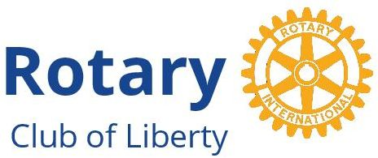
For Immediate Release
January 16, 2018
Contact:
Gary Siegel
845 798-2188
haasiegel@aol.com

Liberty, NY Rotarians Seek Your Donations For
Puerto Rico Hurricane Relief

Relief areas are flu, tetanus and diphtheria vaccinations, shelter-restoration supplies, food, clean-water and home supplies, and toys for children

Relief partners are Rotarians in Southern Catskills, Hudson Valley, Massachusetts and Puerto Rico, Operation Endeavor, and Wings of Michael

January 16, 2018 – Liberty, NY – The Liberty, NY Rotary Club, with a motto of “service above self,” is seeking your donations for a hurricane-relief drive to support victims of Hurricane Maria, which struck Puerto Rico last September 20. The drive targets Moca, a municipality in the northwest corner of the island that was one of the hardest-hit areas of the nearly-Category 5 hurricane. The four relief areas for which community donations are being sought are:
1. Flu, tetanus and diphtheria vaccinations 3. Food, clean-water and home supplies
2. Shelter-restoration supplies 4. Toys for children

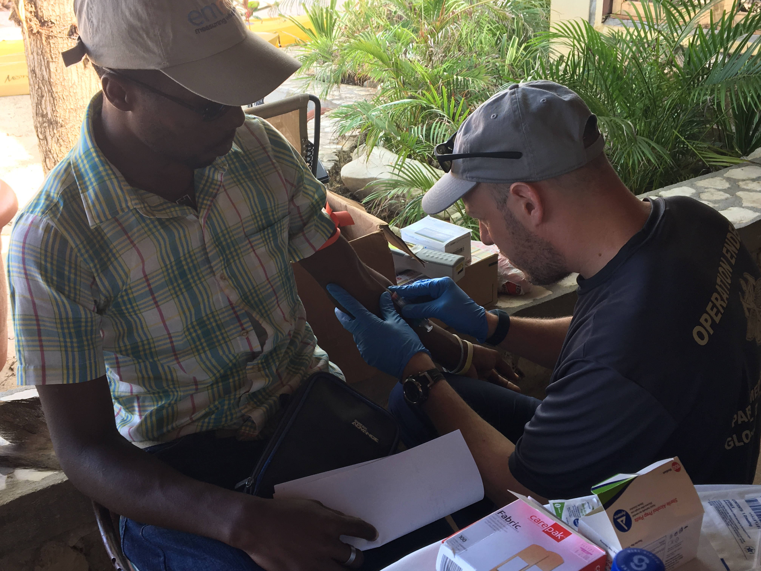
The Liberty, NY Rotary Club kicked-off this fundraising effort just before the new year and has already raised close to $10,000 toward their goal of $25,000. In addition, Central Massachusetts and Metrowest Rotary District 7910 has kicked-off their fundraising efforts by providing a $25,000 grant to supplement another $25,000 in donations being collected by Rotary, Rotaract and Interact clubs. The $25,000 grant is enabled by The Rotary Foundation, one of the highest-rated organizations by Charity Navigator, whose mission is to “do good in the world” through the more than 1.2 million Rotarians around the world.
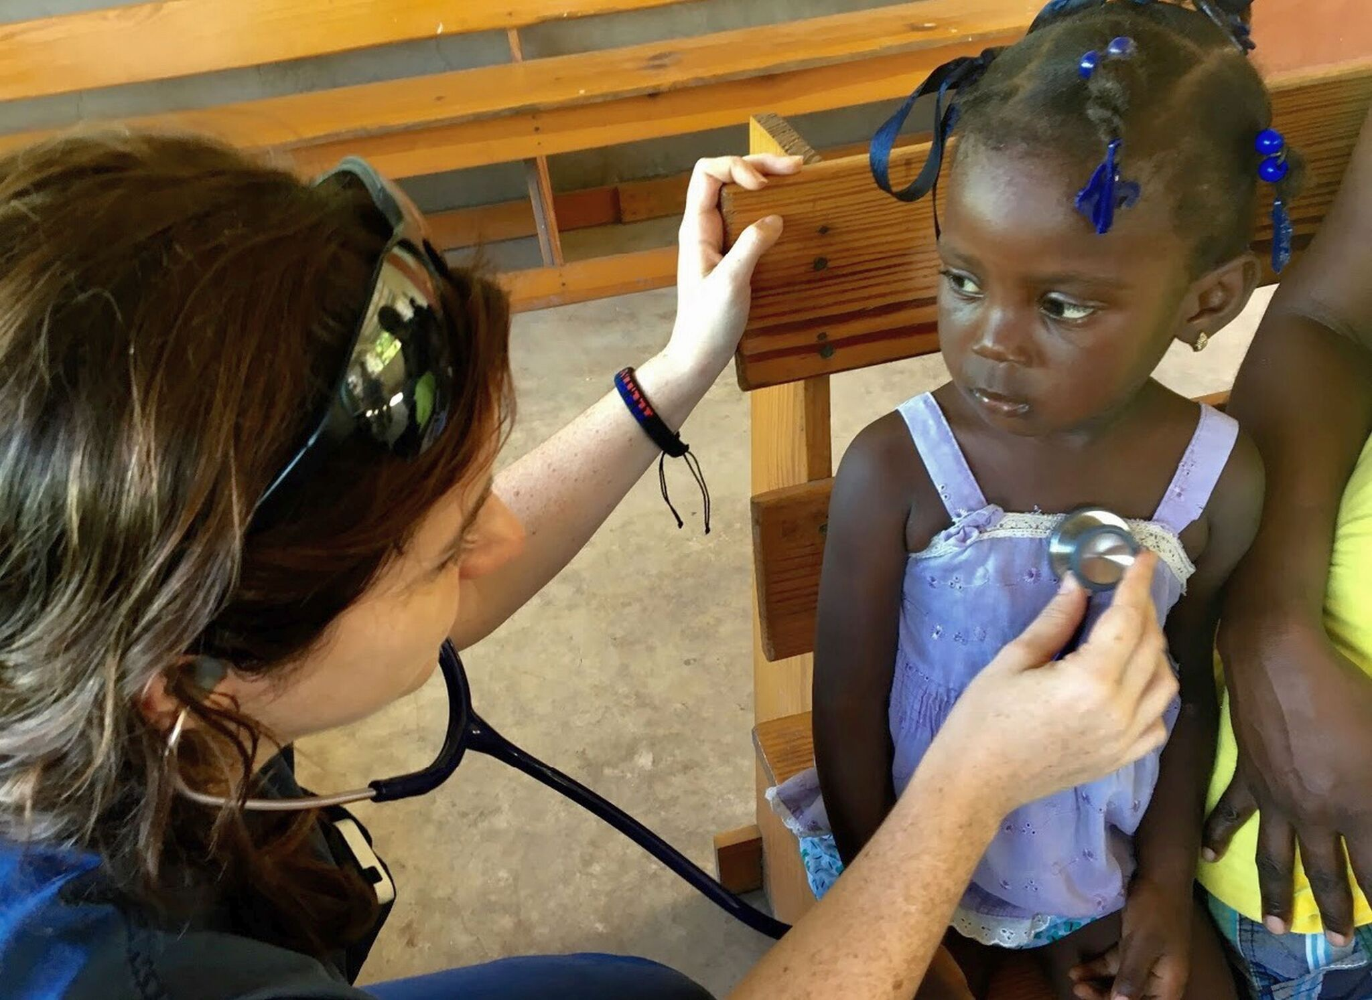
Shown Above: Operation Endeavor member Charles “Chuck” Atwell (right) administers a vaccination shot to a resident (left) from Ile Vache, Haiti on a recent Liberty, NY Rotary Club and Operation Endeavor Hurricane Relief Mission to Haiti.
“One-hundred percent of the funds raised for these hurricane-relief efforts will be overseen by the Rotary Club of Moca, to purchase and distribute supplies and administer vaccines for disease prevention to those families in need,” states Gary Silver, Immediate Past President of the Liberty Club.

Shown left, is a Haitian resident (right) receiving a heart check-up from Emily Cote Ruegg, Operation Endeavor volunteer (left) during a recent Hurricane Relief Mission to Haiti
To donate to the Moca hurricane-relief effort, make your check payable to “CFOS - Liberty, New York, Rotary Club Foundation” On the check’s memo line, note that the donation is for “Hurricane Relief for Puerto Rico.” Mail your check to: CFOS – Liberty NY Rotary Club Foundation, 30 Scotts Corners Drive Suite 203, Montgomery, NY 12549 or online go to https://cfosny.org/project-funds/liberty-new-york-rotary-club-foundation-fund/ and click on the “Donate Now” button through Paypal to donate with a credit card.

Because the Liberty NY Rotary Club Foundation at (CFOS) Community Foundation of Orange and Sullivan is a 501(c)3 charitable, non-profit organization, all donations are tax deductible as allowed by the federal tax laws. “All supplies and toys will be purchased in Puerto Rico by Moca Rotary, to help stimulate the local economy devastated by the hurricane,” states Gary Siegel, treasurer of the Liberty NY Rotary Club and a member of the Hurricane Relief Committee.

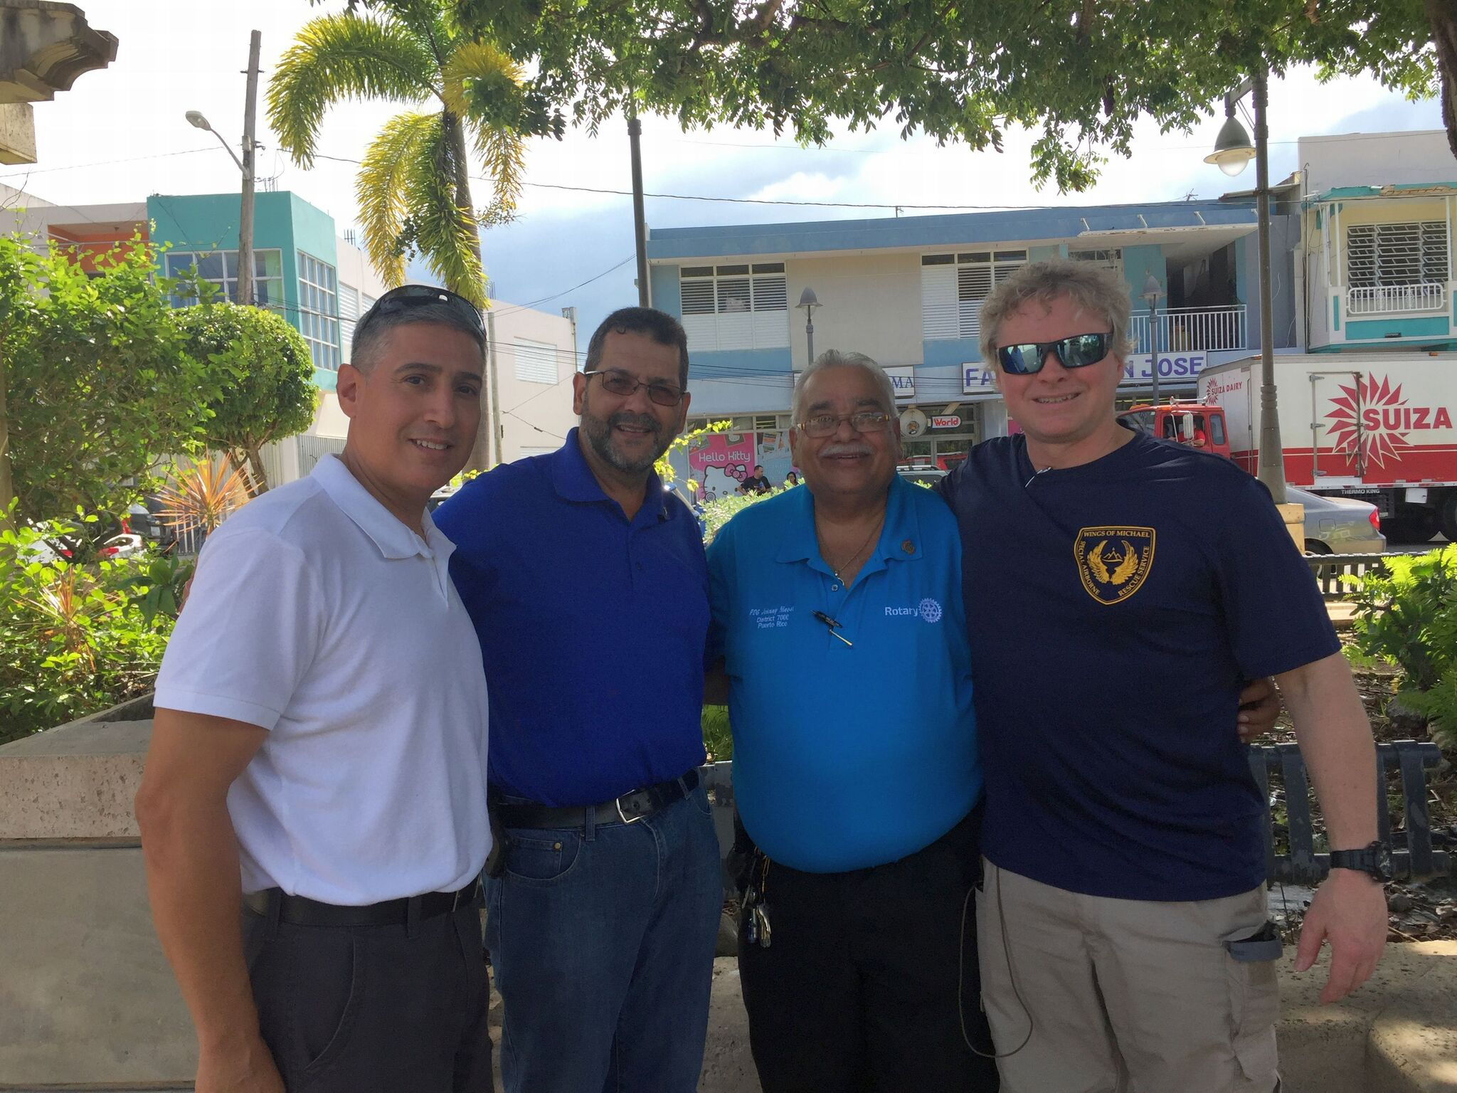
The Liberty, NY Rotary Club is partnering with the Moca Rotary Club and four other non-profit organizations in the Moca relief effort. They are: Rotary District 7000, which covers Puerto Rico and includes the Moca Rotary Club; Rotary District 7910, which serves Central Massachusetts and Metrowest; Operation Endeavor, based in Monticello, New York, which supports public health and safety, EMS-system development, and disaster preparedness in developing regions of the world; and, Wings of Michael, Special Airborne Rescue Service, also based in Monticello, which is a contemporary military order devoted to the rescue and protection of those at risk of injury and death from disaster and oppression.

Shown, left to right, in Moca are: Nelson Quinones, 2017-2018 President of the Moca Rotary Club; Moca Mayor Jose Enrique Aviles; Johnny Nieves, Past Governor of District 7000; and Stu Hirsch, a member of Liberty, NYF Rotary Club and President and Founder of Operation Endeavor and Wings of Michael.
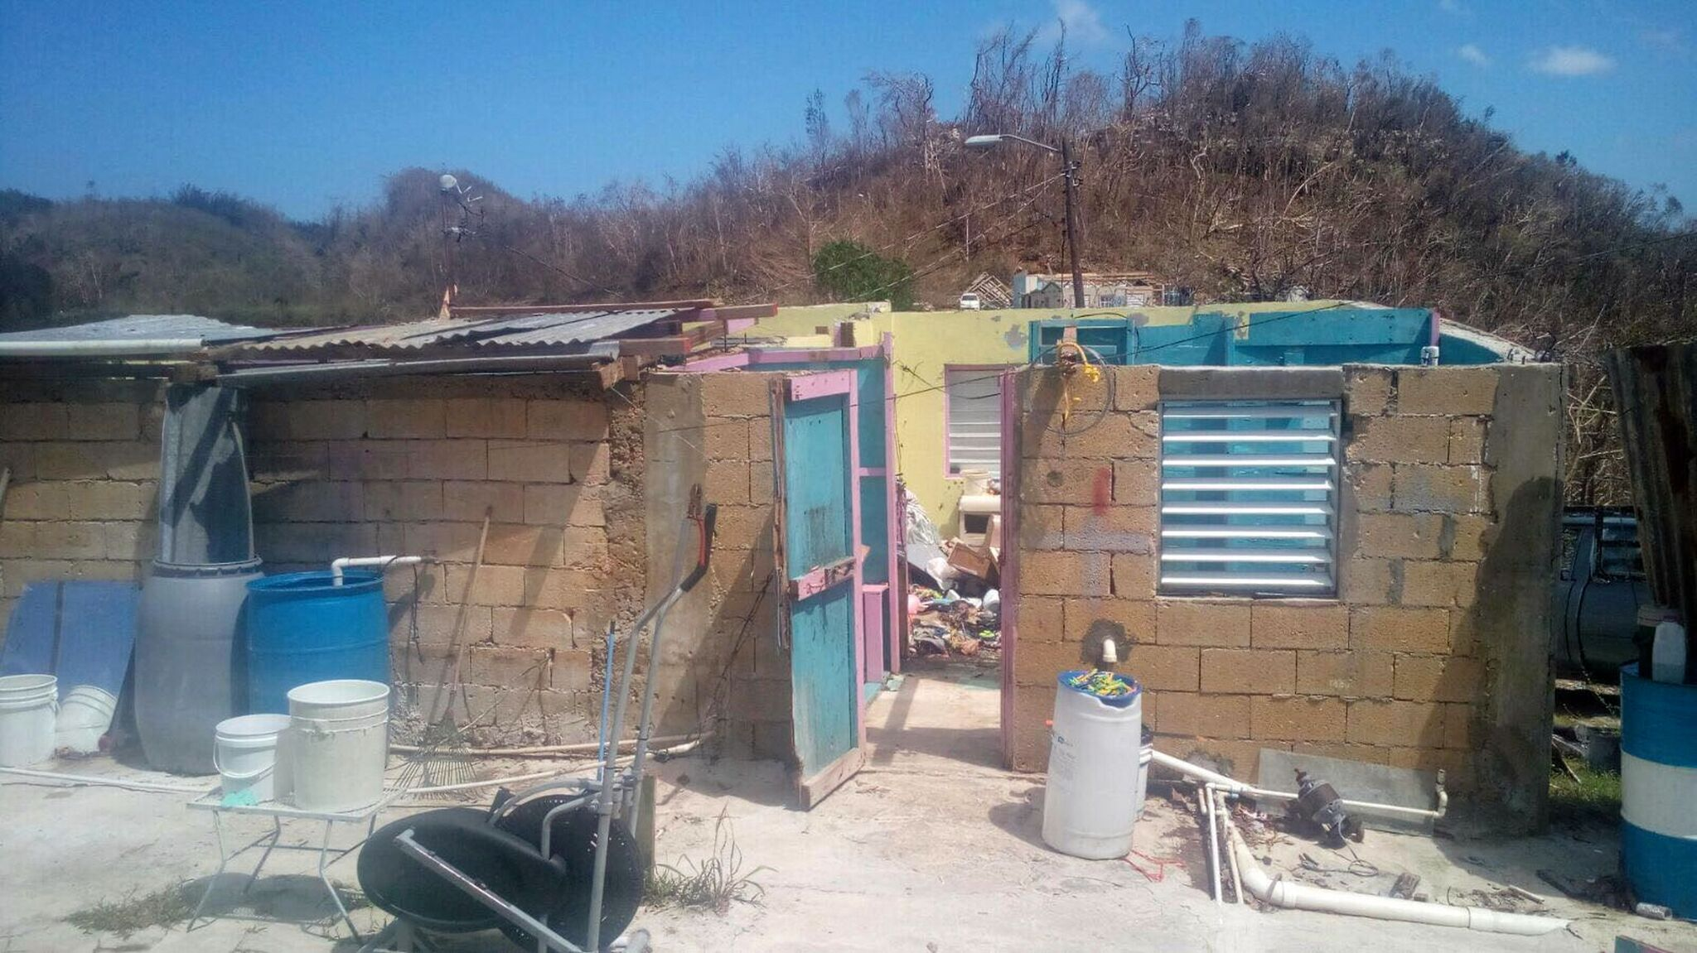
Shown (left), is a Moca home destroyed by Hurricane Maria.
A partnership team consisting of the Liberty, NY Rotary Club, Operation Endeavor, Wings of Michael and Rotary District 7910 will travel this February 2 through 5 to Moca for a hurricane-relief mission. The team will participate in relief-effort activities coordinated by Nelson Quinones, President of Moca Rotary Club, Dr. Lemuel Soto, MD of Moca, Jose Enrique Aviles, Mayor of Moca, and Father Cora and Father Juan of Our Lady of Monserrate Parish in Moca. Those activities will include providing flu, tetanus, and diphtheria vaccination clinics; shelter-restoration supplies; food, clean-water and home supply distributions like much needed mattresses; and toy distributions to children who sustained total losses during the hurricane and may not have received any during the holidays.

Members of the mission team from the Liberty, NY Rotary Club include Judy Siegel, President, Gary Silver, immediate Past President and VP of Governmental and Legal Affairs for Operation Endeavor, Gary Siegel, Treasurer and Director of Operation Endeavor, Stuart Hirsch, President and Founder of Operation Endeavor and Wings of Michael and member of the Liberty NY Rotary Club, Irving Kaplan, member of the Liberty Rotary Club, and Tommy Andryshak member of Operation Endeavor. Participating from District 7910 in the February mission are: Teri Siegel Banerjee, Director of the Rotary Club of Framingham; and Michael Dexter-Smith, a member of the Rotary Club of Weston & Wayland.

For more information, contact Gary Siegel, at 845 798-2188 or haasiegel@aol.com or contact the CFOS (Community Foundation of Orange and Sullivan) at 845 769-9393

About Rotary International, Liberty, NY Rotary Club and Rotary District 7910
Rotary International is a global network of 1.2 million neighbors, friends, leaders, and problem-solvers who come together to make positive, lasting change in communities at home and abroad. For more than 110 years, Rotary members have used their passion, energy, and intelligence to take action on sustainable projects.
The Liberty, NY Rotary Club is one of 62 clubs in Rotary District 7210. The Liberty NY Rotary Club has close to 30 members from the Liberty, NY community who are dedicated to putting service above self locally, nationally, and internationally. (www.libertynyrotary.org)
Rotary District 7910 serves more than 50 Rotary clubs in Central Massachusetts representing more than 1,500 Rotarians. The mission of Rotary is to provide “service above self” by serving others, promoting integrity, and advancing world understanding, goodwill, and peace through our fellowship of business, professional, and community leaders. Rotary’s charitable, non-profit organization's efforts are driven by five core values: Service, Fellowship, Diversity, Integrity and Leadership. Rotary members work together to identify community needs on a local, national and global level, and then leverage their resources to enable solutions.
About Operation Endeavor
Operation Endeavor is comprised of EMS, Emergency Medicine and Rescue professionals and is incorporated as an M99 501(c)(3) that operates domestically and globally to build capacity for EMS and Rescue systems in regions of disparity. The team is also active in disaster response. (www.911ForTheWorld.org

About Wings Of Michael S.A.R
Wings of Michael is a faith-centric religious X99 501(c)(3) non-profit (dedicated to the spiritual charism of Michael the Archangel) that provides reconnaissance and rescue services, often incorporating aviation resources, to populations that are beset by natural disaster or acts of sectarian violence and refugee displacement. (www.WingsOfMichael.org)

-END-

